Instruction on how to upload supplier quote from Excel

The supplier quote upload process would involve the following steps:
- Launch screen Supplier Quote Upload under menu PUR -> Sourcing shown as below.
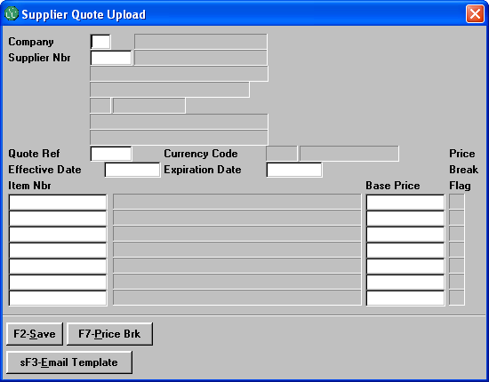

- Use sF3-Email Template to select a Supplier Quote Excel Template with or without sample data, and have it send to you by email.
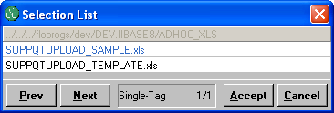

The sample Supplier Quote Excel Template looks like as below
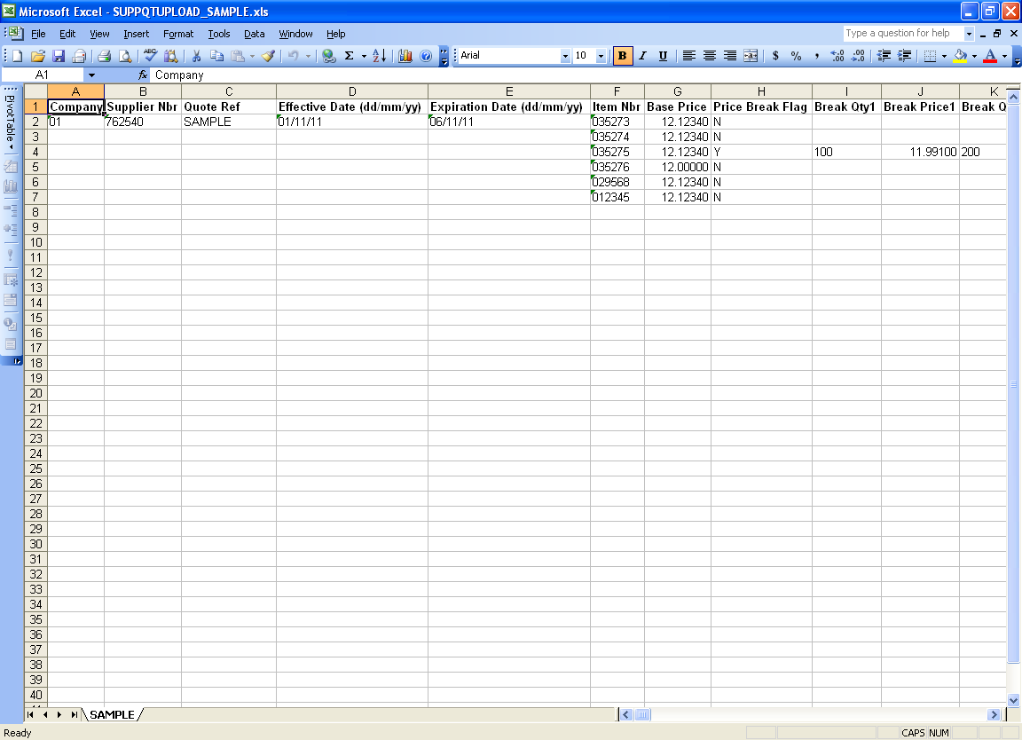
  - All price cells are preformatted as a real number with 5 decimal digits and the rest cells are all in text format in order to be consistent with the data in Infoflo.
  - Please do not change the data format on any cells within the template, and make sure the name of the worksheet name (not the name of the excel file) is the same as Quote Ref.

- Enter Company 01, Supplier Nbr 762540, Quote Ref SAMPLE for example, these information should match exactly with the ones on the source supplier quote excel worksheet. The name of the source supplier quote excel worksheet also has to be the same as the Quote Ref.
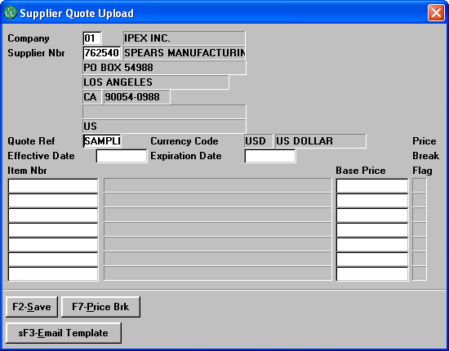

- On the Quote Ref field, press Enter to continue. If the source supplier quote excel worksheet is already opened, the program will start to do the upload process immediately, otherwise, an open file dialog box will be pop up to ask for the source file and then open it in order to start the upload process. For performance perspective, it’s better to have the supplier quote excel opened prior to do the upload.
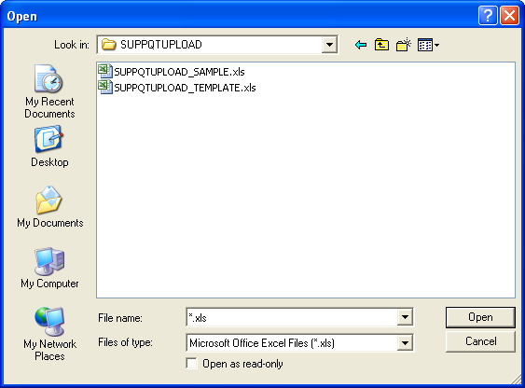

Locate the supplier quote excel file and click on button Open to start the upload process, once the upload is started, you will see a progressing bar on the bottom of the Infoflo screen growing to indicate the status of the current upload process. When the upload is done, you should see a similar screen as below.
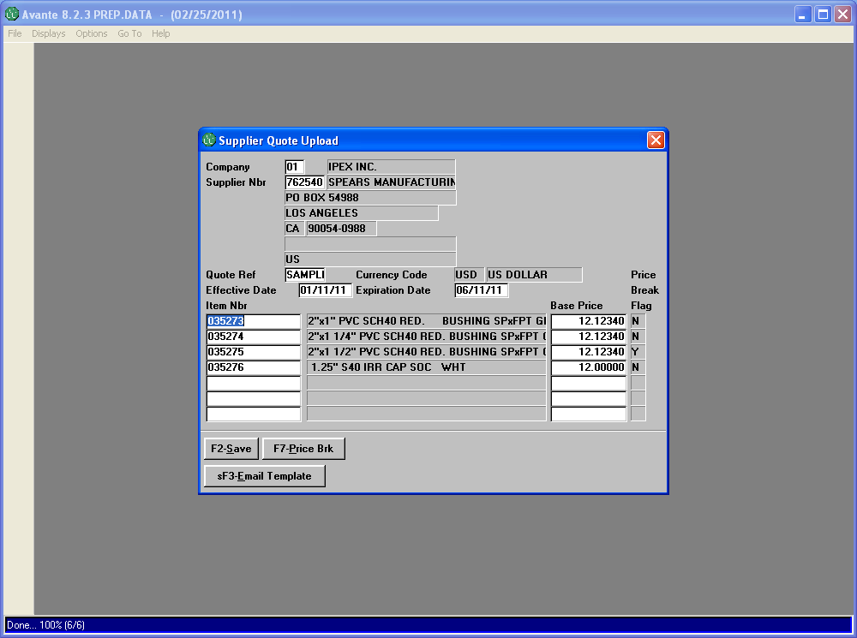

- There will be an email sent to you if there is any errors found for the items in the source supplier quote excel worksheet during the upload process.
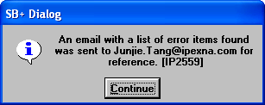

- Once you are ready, simply click on F2-Save to save the supplier quote in the system. A confirmation dialog box will be shown after you press F2.
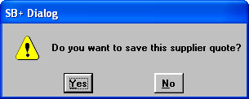

Note:
  - Any invalid item numbers found in the source supplier quote worksheet will be discarded including those that do not have an Item/Supplier Source relationship established.
  - If the price break is not applicable for a quote, you can leave the Price Break Flag as blank, same to the Break Quantity and Break Price.
  - Quote expiration date is optional.
  - Overwriting an existing quote is not allowed.

